**Math 120  
2.6 Linear Inequalities**

# **Objectives:**

1. Solve linear inequalities.
2. Recognize inequalities with no solution, or with all real numbers as solutions.
3. Solve compound inequalities.

# **Topic #1: Solving Linear Inequalities in One Variable**

Linear inequalities are similar to linear equations. They are solved the same way, but they differ in how the solution set is expressed. Consider the linear equation and its solution:

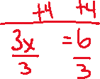

The solution is finite (only one distinct number) and the equation is TRUE when plugging it back in the equation. The solution was achieved by solving for .



Consider the linear inequality:



This is asking for all values of that make the left side of the inequality “greater than” 2. To solve, isolate the variable the same way. The inequality symbol replaces the equal symbol:

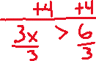

The solution set is not a finite set of numbers, it is an interval of values (specifically, all numbers greater than 2). Any value greater than 2 makes the inequality TRUE. The solution set can be expressed as an interval:



The solution set can also be graphed on a number line:



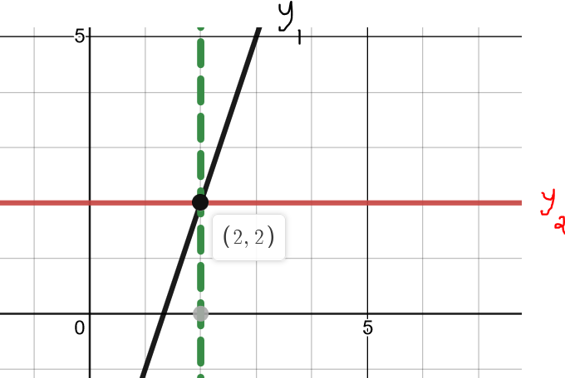The inequality can also be solved graphically,

where and :

Notice that the left side of the inequality is above the right side for all values .

*Example #1* – Solve the Linear Inequality; Write Solution as an Interval

a.



The interval can also be graphed on the number line:



The solution can also be determined by graphing

and and looking where :

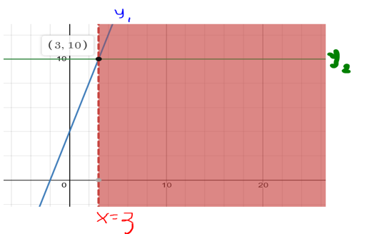

b.



**When we divide by a negative the inequality symbol reverses**



The interval can also be graphed on the number line:



The solution can also be determined by graphing

and and looking where

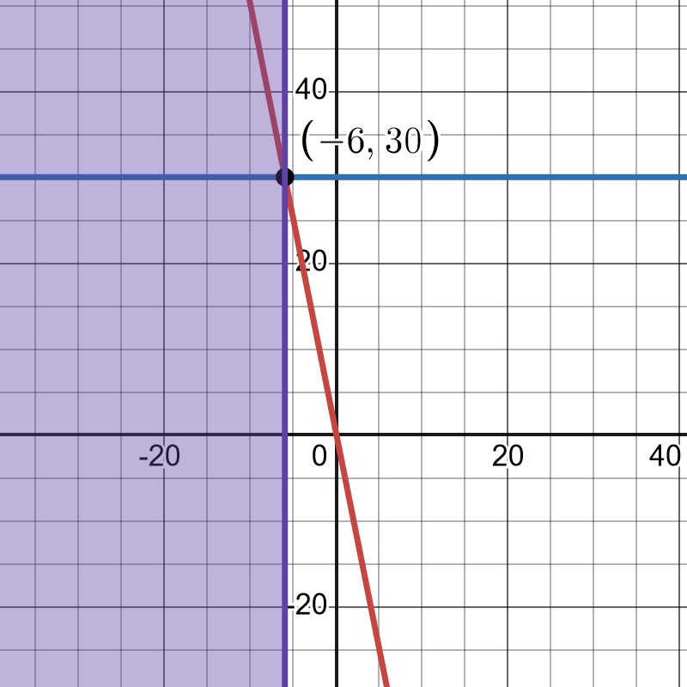

c.

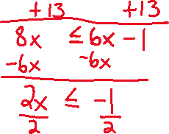

The solution set on the number line:



The solution determined by graphing, with

and

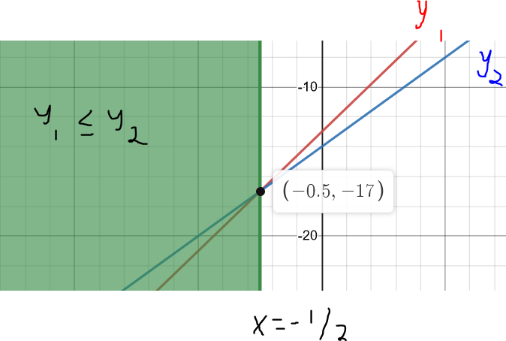

d.

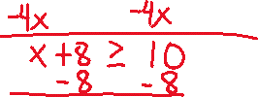

The solution set on the number line:



The solution determined by graphing, with

and

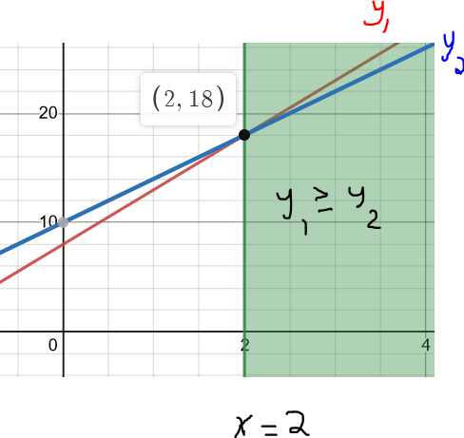

e.



The variables canceled and the inequality is TRUE, the solution set is **________________________________**



A graph shows the line on the left side is ALWAYS below/less than the line on the right side:

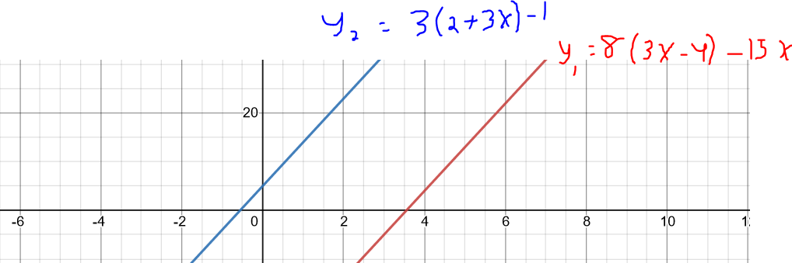

f.



The variables canceled and the inequality is FALSE, the solution set is empty or **_________________________**



A graph shows the line on the left side is ALWAYS above/greater than the line on the right side, making it impossible for the left side to ever be below/less than the right side:

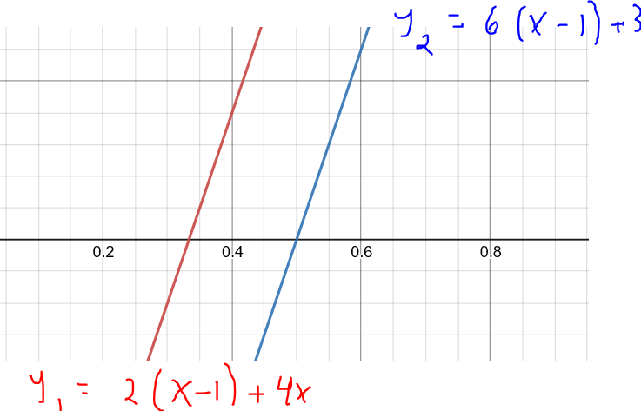

*YOU TRY #1* – Solve the Linear Inequality; Write Solution as an Interval, graph the solution on a number line, and use your graphing calculator to check.



a. b.

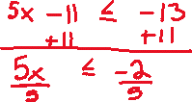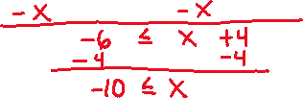

c. d.



# **Topic #2: Solving a Compound Linear Inequality in One Variable**

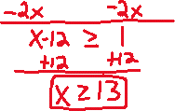

A compound linear inequality involves a line bound between two values, for example consider the inequality:

To solve, we isolate the __________________________ **Whatever is done to the middle is done to the ends;** here we subtract 4 and divide by 2 to all parts:

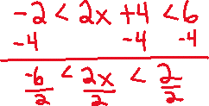

The solution set is where the line is between and (not inclusive) along the -axis. A graph confirms the solution set:

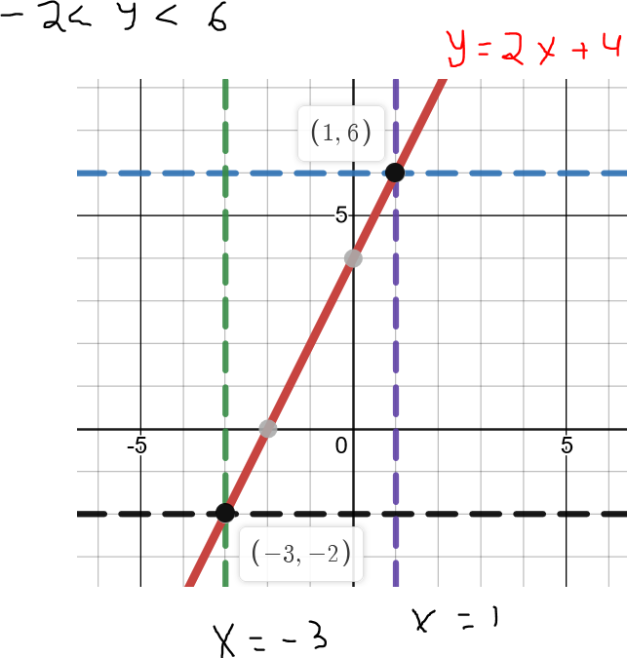

*Example #1* – Solve the Linear Inequality; Write Solution as an Interval

a.



b.

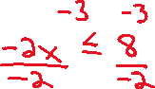

*YOU TRY #2* -

# **Topic #3: Applications of Linear Inequalities**

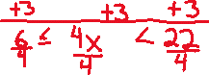

*Example #1* – Construct and Solve the Linear Inequality

Car Rental Company A charges $4 a day plus $0.15 per mile to rent a car. Car Rental Company B charges $20 a day plus $0.05 per mile to rent a car. Suppose a person wants to rent a car for one day.



a. Write a function the models the daily cost and number of miles driven for Company A.

Let x be:



Let f(x) be:



b. Write a function the models the daily cost and number of miles driven for Company B.



Let x be:



Let g(x) be:

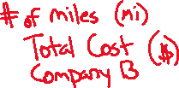

c. How many miles driven in a day will make Company B the better deal?



The better deal is when one company costs ___________ the other. To find out how many miles makes Company B the better deal, we want to know what makes :

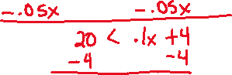

Here we look at the solution graphically:

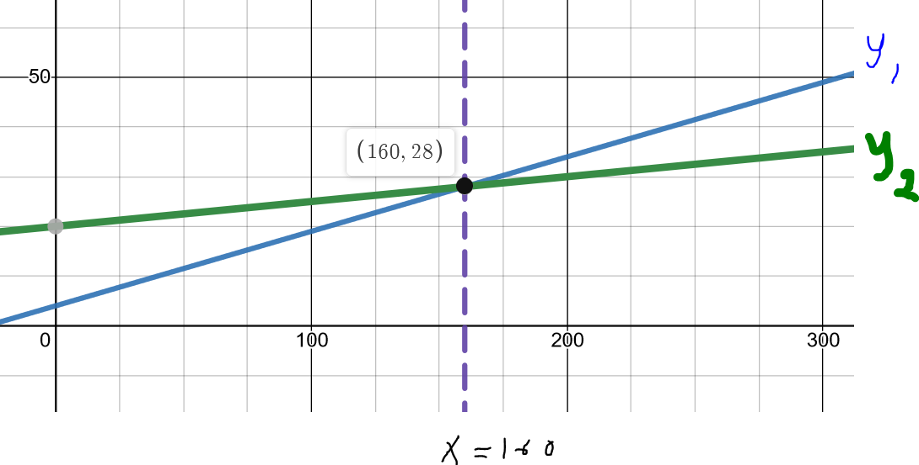

The graph shows when __________________



This tells us if the person drives more than _______________ then Car Company B is the better deal (conversely, Car Company A is the better deal if the person drives less than 160 miles).



*Example #2* – Construct and Solve the Linear Inequality

Parts for a certain automobile repair costs $175 and a mechanic charges $32/hour for labor.



a. Write a function that models the cost to repair the automobile and the number of hours worked.

Let x be:



Let f(x) be:



b. Suppose the estimate for the repair is between $223 and $287. What is the time interval that the mechanic will be working on the repair?



The actual cost is estimated to be between $223 (in the low end) and $287 (on the high end). This gives the resulting compound inequality, solving for will give the time interval:

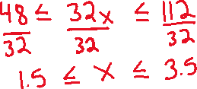

This tells us the mechanic will work between_________________________________



Feel free to solve graphically!

*Example #3* – Construct and Solve the Linear Inequality

An elevator at a construction site that lifts cement bags has a maximum capacity of 2800 pounds. The elevator operator weighs 265 pounds and must ride in the elevator at all times; each bag of cement weighs 65 pounds.

a. Write a function that models the weight on the elevator and the number of bags of cement.

Let x be:



Let g(x) be:



b. What is the greatest number of cement bags that can be safely lifted in one trip?

The maximum capacity is 2800 pounds, which means the weight cannot exceed that value. This is another way to say _____________________________



This gives the inequality:

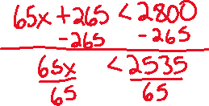

This tells us that elevator can safely support at most ________________________with a 265-pound operator.

